

**Tracking Anime**

|  |  |  |
| --- | --- | --- |
| **Supervisor:** | *LÊ THANH NHÂN* | |
| **Semester:** | *II* | |
| **Batch No:** | *T5.2306.E1* | |
| **Group No:** | *2* | |
| **Order:** | **Full name** | **Roll No.** |
| *1.* | *Lê Vinh Chí* | *Student1477477* |
| *2.* | *Nguyễn Trần Hoàng Long* | *Student1470292* |
| *3.* | *Lê Trương Tín* | *Student1470125* |
| *4.* | *Nguyễn Hoàng Anh Tú* | *Student1470285* |

***Month****: 04* ***Year****: 2024*



This is to certify that.

|  |  |
| --- | --- |
| **Mr.** | **Lê Vinh Chí** |
| **Mr.** | **Nguyễn Trần Hoàng Long** |
| **Mr.** | **Lê Trương Tín** |
| **Mr.** | **Nguyễn Hoàng Anh Tú** |

Have successfully Designed & Developed

|  |  |  |  |  |
| --- | --- | --- | --- | --- |
|  | |  |  |  |
|  | **Tracking Anime** | | | |

Submitted by:

|  |
| --- |
| **Mr. LE THANH NHAN** |

Date Of Issue:

|  |  |
| --- | --- |
|  |  |

Authorized Signature:

|  |  |
| --- | --- |
|  |  |
| **Content** | | | |

Content

Acknowledge

Synopsis

Review1 (điền số trang theo thực tế)

Review2 (điền số trang theo thực tế)

Review3 (điền số trang theo thực tế)

Testing Document (điền số trang theo thực tế)

Final Checklist (điền số trang theo thực tế)

Tasksheet (điền số trang theo thực tế)

|  |
| --- |
| **Acknowledge** |

For regular anime viewers, an app for tracking anime to efficiently manage and organize anime series is essential. To have a comprehensive app, some necessary features include:

Progress tracking:

* + Marking episodes, you've watched and tracking the next ones.
  + Viewing your anime viewing history.
  + Receiving notifications for new episode releases.

List management:

* + Creating lists for favorite, currently watching, plan to watch, and watched anime.
  + Sorting and filtering lists based on various criteria.
  + Sharing your lists with friends.

Anime discovery:

* + Searching for anime by name, genre, airing season, etc.
  + Browsing through popular, highly rated, and upcoming anime lists.
  + Reading detailed information about anime, including summaries, character lists, ratings, etc.

Community:

* + Participating in anime discussions with other users.
  + Joining community groups based on shared interests.
  + Sharing your thoughts and reviews about anime.

Therefore, our team will strive to implement this exciting project. We hope everyone will use it effectively and provide positive feedback.

|  |
| --- |
| **Synopsis** |

Tracking Anime is a system would maintain a comprehensive database of anime series, including their titles, genres, release dates, and synopses.

Users would create profiles within the system, allowing them to customize their preferences and track their interactions with different anime series.

Users could browse through the database to find anime series they're interested in. For each series, they could view a synopsis to get an overview of the plot, characters, and themes.

Users could mark whether they've read the synopsis of a particular anime series or not. This feature would help them keep track of which series they've explored and which ones they still need to review.

The system could use algorithms to analyze users' viewing preferences and provide personalized recommendations for anime series with synopses that match their interests.

Users could engage with other members of the community to discuss synopses, share recommendations, and exchange insights about different anime series.

The system could send notifications to users about newly added synopses, upcoming anime releases, or relevant community discussions.

**Review 01**

|  |
| --- |
| **Problem Definition** |

Addressing the Needs of Anime Enthusiasts with a Comprehensive Tracking App Anime enthusiasts, or "wibu" as they are often called, have a constant need for an efficient and organized way to track and manage their vast anime collections. To solve this demand, we propose the development of a comprehensive anime tracking application that caters to the specific needs of anime aficionados.

Key Features:

* Seasonality Awareness: Stay updated on new anime releases and identify intriguing shows for the upcoming season.
* Progress Tracking: Keep track of your progress in each anime series, ensuring you never miss any episodes. Maintain a comprehensive history of your anime viewing journey. Receive timely notifications for new episode releases.
* Personalized Management: Create and manage personalized anime lists based on your preferences: favorites, status (currently watching, plan to watch or completed), etc. Implement effective sorting and filtering mechanisms to organize your lists effortlessly. Share your curated lists with fellow anime enthusiasts.
* Anime Discovery: Seamlessly search for anime by title, genre, release season, and other relevant criteria. Explore curated lists of popular, highly rated, and upcoming anime titles. Delve into detailed anime information, including summaries, character profiles, reviews, and more.

Our Commitment: Our team is dedicated to bringing this exciting project to life, meticulously crafting an anime tracking app that caters to the specific needs of anime enthusiasts. We envision a tool that enhances the anime viewing experience, fostering a sense of community and empowering users to manage their anime collections with utmost efficiency.

We sincerely invite you to join us in this journey and welcome your constructive feedback to ensure we deliver an exceptional anime tracking app that exceeds expectations.

|  |
| --- |
| **Customer Requirements Specifications** |

1. **CRS/Requirements Specifications**

|  |  |  |
| --- | --- | --- |
| Client/Project Undertaken: | | |
| 1. | List of inputs to the system | |
|  | *-* | User data registration |
|  | *-* | Tracking anime list |
|  |  |  |
|  |  |  |
| 2. | List of outputs expected from the system | |
|  | *-* | Tracking record |
|  | *-* | Anime record |
|  | *-* | Notification |
|  |  |  |
| 3. | Overview of processes involved in the system | |
|  | - | Login |
|  | - | Display Anime Data |
|  | - | Picking and Saving Tracking Anime List |
|  | - | Checking Timeline of Anime |
|  |  |  |
|  |  |  |

|  |  |  |
| --- | --- | --- |
| Admin/Project Undertaken: | | |
| 1. | List of inputs to the system | |
|  | *-* | Account role data |
|  | *-* | Anime List Information |
|  |  |  |
|  |  |  |
| 2. | List of outputs expected from the system | |
|  | *-* | Process account data and Role account |
|  | *-* | Anime record |
|  | *-* | Accounts record |
|  |  |  |
| 3. | Overview of processes involved in the system | |
|  | - | Account role information |
|  | - | Modify accounts |
|  | - | Manage anime list |
|  |  |  |

|  |  |
| --- | --- |
| Hardware and software required for implementing the project | |
| 1. | *Operating system: Windows 10 higher* |
| 2. | *Hardware: CPU Cores with 2 Gigabytes of RAM or better* |
| 3. | *Font Unicode: Arial, Tahoma, Lucida Console, Times New Roman, etc…* |
| 4. | *Other requirement: A working internet connection* |

1. **CRS/Customer Acceptance Criteria**

|  |  |
| --- | --- |
| **S.No** | **Customer's Acceptance Criteria** |
| 1 | Given that app was opened, when user register account then admin checks and confirms whether to create an account. |
| 2 | Given that app was opened, when customer (admin, user) enters valid credentials then the system grants access. |
| 3 | Given admin login successfully, when admin modifies anime details then the system stores it. |
| 4 | Given user login successfully, when user adds new tracking anime then the system stores it. |
| 5 | Given user login successfully, when selects tracking anime then the system confirms and removes it. |
| 6 | Given user login successfully, when user edits anime details then the system saves the changes. |
| 7 | Given user login successfully, when user requests the list, and the system displays all anime. then the system displays all anime. |
| 8 | Given user login successfully, when user searches or filters then the system displays matching anime. |
| 9 | Given that it's been a day, when there are new episodes or releases for tracked anime then notify the users. |

1. **Project Plan**

|  |  |
| --- | --- |
| 1. Project Details | |
| + | Name of the Client: Tracking Anime |
|  |  |
| + | Date of Project Plan: April 2024 |
|  |  |
|  |  |
|  |  |
| + | Project Vision/Objectives: |
|  | Tracking Anime empowers users to conveniently track, manage, discover, and share their anime collections. Our application runs on a Desktop Application platform, providing distinct user and admin roles with specific privileges. |
|  |  |
|  |  |
| + | Scope: |
|  | * Core Functionality: Anime Data Management, Tracking and Management, List Creation and Management, Community Features * Platform: Only Desktop * Data Persistence: Only Local (SQL Server) * Testing: Ensure functionality and user experience |
|  |  |
|  |  |
| + | Our understanding of the client organization: |
|  | MyAnimeList is one of the anime tracking websites that I know of that is relevant today. This is a website that manages hot, seasonal anime series from many years ago and up to now |
|  |  |
|  |  |
| + | Project Organization with Responsibilities and Authorities: |
|  | The roles: |
| - | Project Team Leader (PTL) |
| - | Designer |
| - | Developer |
| - | Tester |
|  | The task: to get references in TaskSheet |
| 2. Project Initiation/Requirement Documents | |
| - | Design Documentation |
| - | Installation Guide |
| - | User Guide |
|  |  |
| 3. Deliverables | |
| - | Design Documentation |
| - | Installation Guide |
| - | User Guide (include of maintenance Manual) |
| - | Source Code |
| 4. Project Dependencies | |
| - | New technology by JavaFX |
|  |  |
|  |  |
|  |  |
| 5. Major Project Milestones | |
| - | Review 1 |
| - | Review 2 |
| - | Review 3 |
|  |  |
| 6. Quality Plan | |
| + | Review Activities: |
| - | Review meeting |
| - | Development meeting |
|  |  |
|  |  |
| + | Testing Activities and Backup and recovery strategies: |
| - | Final meeting |
|  |  |
|  |  |
|  |  |
|  |  |
|  |  |
|  |  |
|  |  |
|  |  |

**Review 02**

|  |
| --- |
| **Architecture and design of the Application** |

1. **Application Architecture**



**Figure 1.1:** Two-Tier Architecture of the Project

1. **Data Flow Diagram**

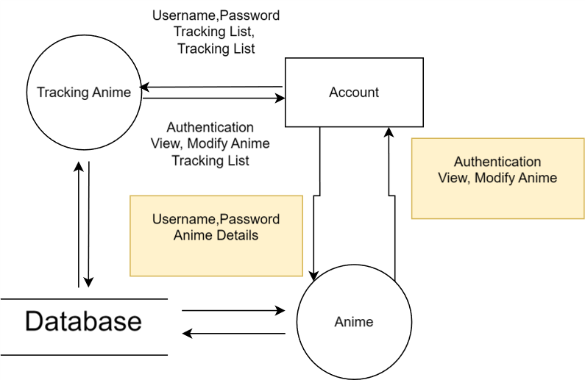

**Figure 1.2:** DFD level 0

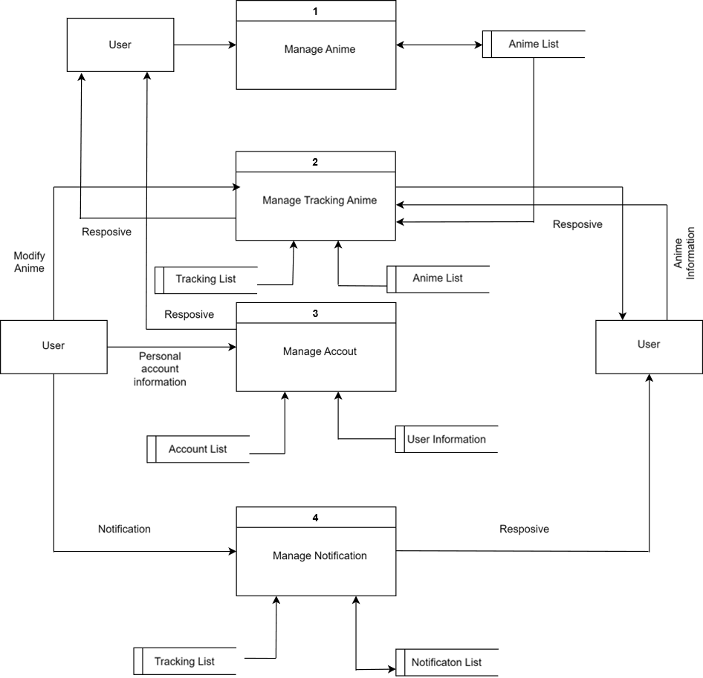

**Figure 1.3:** DFD level 1

|  |
| --- |
| **Entity Relationship Diagram** |

1. **ERD**

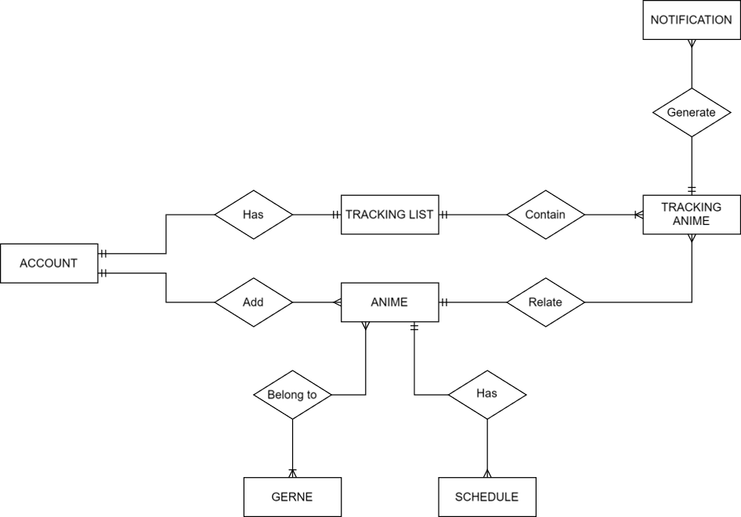

1. **ERD Properties**
   * **Account**

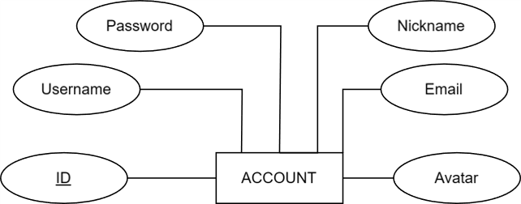

* + **Gerne**

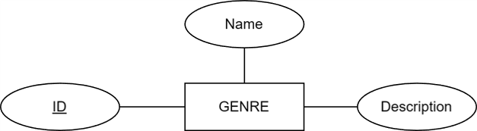

* + **Schedule**

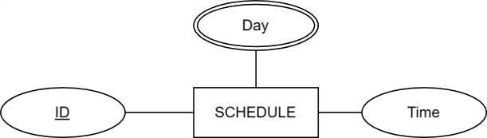

* + **Anime**

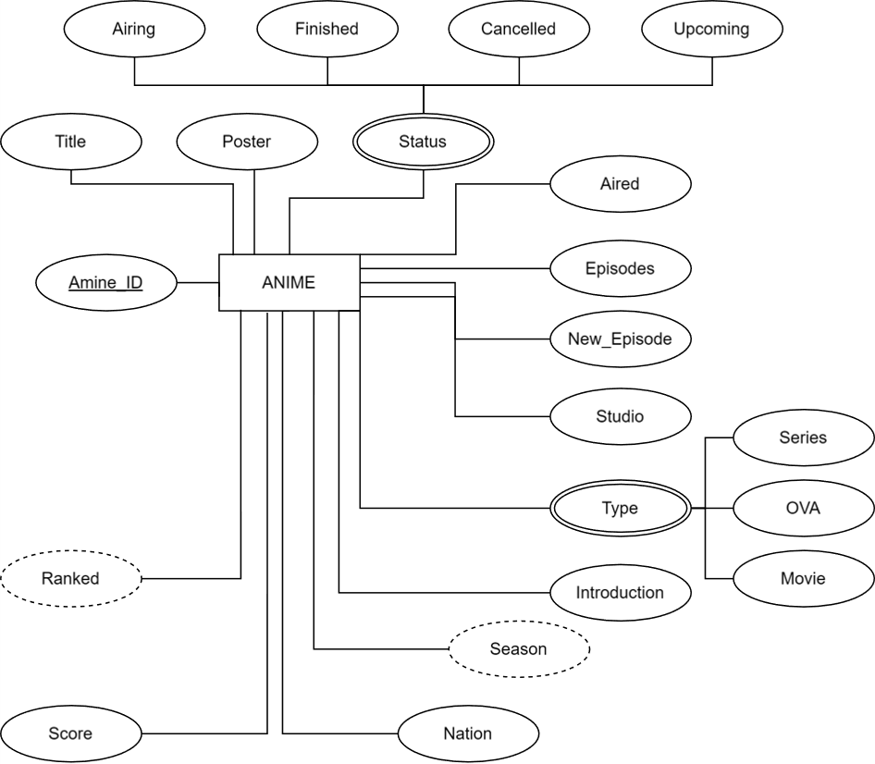

* + **Tracking List**

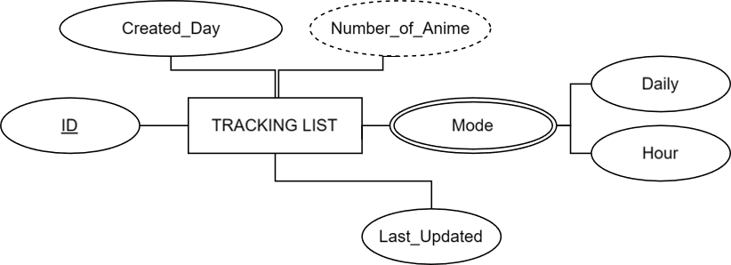

* + **Tracking Anime**

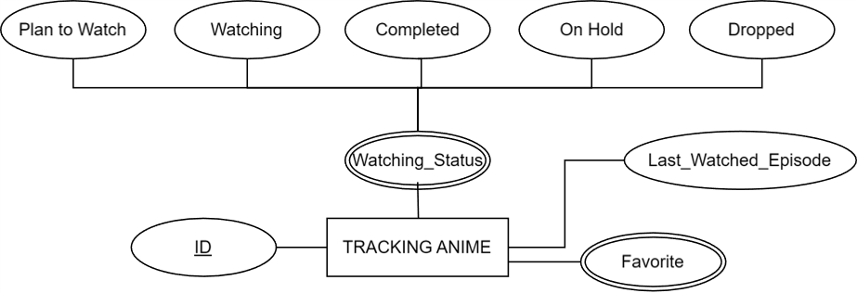

* + **Notification**

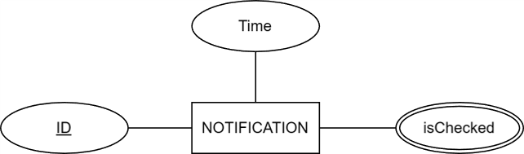

|  |
| --- |
| **Table Design** |

1. **Table Design**
   1. **Account**

|  |  |  |  |  |  |
| --- | --- | --- | --- | --- | --- |
| **Account** | | | | | |
| Serial | Fields | Data type | Keys | Constrains | Description |
| 1 | account_id | INT | PRIMARY KEY | IDENTITY,  AUTO INCREMENT | Account identification |
| 2 | username | VARCHAR(50) |  | NOT NULL, UNIQUE | Account owner’s name |
| 3 | password | VARCHAR(32) |  | NOT NULL | Account’s password |
| 4 | email | VARCHAR(255) |  | NOT NULL, UNIQUE | Account’s role |
| 5 | nickname | NVARCHAR(50) |  | NOT NULL, UNIQUE | Account’s nickname |

* 1. **Genre**

|  |  |  |  |  |  |
| --- | --- | --- | --- | --- | --- |
| **Genre** | | | | | |
| Serial | Fields | Data type | Keys | Constrains | Description |
| 1 | genre_id | INT | PRIMARY KEY | IDENTITY,  AUTO INCREMENT | Genre identification |
| 2 | name | VARCHAR(50) |  | NOT NULL, UNIQUE | Name of Genre |
| 3 | description | TEXT |  |  | Description about Genre |

* 1. **Anime**

|  |  |  |  |  |  |
| --- | --- | --- | --- | --- | --- |
| **Anime** | | | | | |
| Serial | Fields | Data type | Keys | Constrains | Description |
| 1 | anime_id | INT | PRIMARY KEY | IDENTITY,  AUTO INCREMENT | Anime identification |
| 2 | account_id | INT | FOREIGN KEY | NOT NULL,  REFERENCES Account(account_id) | Account Idenfication |
| 3 | title | VARCHAR(50) |  | NOT NULL | Title of Anime |
| 4 | poster | VARCHAR(100) |  |  | Link poster |
| 5 | status | TINYINT |  |  |  |
| 6 | aired | DATETIME |  |  | Release time |
| 7 | episodes | INT |  |  | Number of anime eposides |
| 8 | new_eposide | INT |  |  | New eposide of Anime |
| 9 | studio | NVARCHAR(20) |  |  | Name of Studio |
| 10 | type | TINYINT |  |  | Type of Anime |
| 11 | introduction | NVARCHAR(200) |  |  | Description about Anime |
| 12 | season | TINYINT |  |  | Season |
| 13 | nation | TINYINT |  | DEFAULT 1 | Nation |
| 14 | score | FLOAT |  | DEFAULT 0 | Anime Score |
| 15 | ranked | INT |  | DEFAULT -1 | Ranked Anime |

* 1. **Schedule**

|  |  |  |  |  |  |
| --- | --- | --- | --- | --- | --- |
| **Schedule** | | | | | |
| Serial | Fields | Data type | Keys | Constrains | Description |
| 1 | genre_id | INT | PRIMARY KEY | IDENTITY,  AUTO INCREMENT | Genre identification |
| 2 | anime_id | INT | FOREIGN KEY | NOT NULL, REFERENCES Anime(anime_id) | Anime Indetification |
| 3 | day | TINYINT |  | NOT NULL | Day of Week(2 - Monday, 3 - Tueday, ... , 8 - Sunday) |
| 4 | time | TIME |  |  | Time Anime Airring |

* 1. **GenreWithAnime**

|  |  |  |  |  |  |
| --- | --- | --- | --- | --- | --- |
| **GenreWithAnime** | | | | | |
| Serial | Fields | Data type | Keys | Constrains | Description |
| 1 | PK_ID |  | PRIMARY KEY | CONSTRAINT (anime_id, genre_id) | Genre identification |
| 2 | anime_id | INT | FOREIGN KEY | NOT NULL, REFERENCES Anime(anime_id) | Anime Indetification |
| 3 | genre_id | INT |  | NOT NULL, REFERENCES Genre(genre_id) | Genre Indetification |

* 1. **Tracking List**

|  |  |  |  |  |  |
| --- | --- | --- | --- | --- | --- |
| **TrackingList** | | | | | |
| Serial | Fields | Data type | Keys | Constrains | Description |
| 1 | tl_id | INT | PRIMARY KEY | IDENTITY,  AUTO INCREMENT | Tracking List identification |
| 2 | account_id | INT | FOREIGN KEY | NOT NULL, REFERENCES Anime(anime_id) | Anime Indetification |
| 3 | created_day | DATE |  | NOT NULL | The day the anime list was created |
| 4 | number_of_anime | INT |  | DEFAULT 0 | Number of Tracking Anime |
| 5 | mode | BIT |  | DEFAULT 1 | Mode tracking |
| 6 | last_updated | DATETIME |  |  | Last Updated Time |

* 1. **Tracking Anime**

|  |  |  |  |  |  |
| --- | --- | --- | --- | --- | --- |
| **Tracking_Anime** | | | | | |
| Serial | Fields | Data type | Keys | Constrains | Description |
| 1 | PK_TL_ID |  | Primary Key | Identity, CONSTRAINT (tl_id, anime_id) | Tracking Anime identification |
| 2 | tl_id | INT | Foreign Key | NOT NULL, REFERENCES TrackingList(tl_id) | List tracking identification |
| 3 | anime_id | INT | Foreign Key | NOT NULL, REFERENCES Anime(anime_id) | Anime identification |
| 4 | status | TINYINT |  | Not null | Status of Tracking Anime |
| 5 | last_watched_episode | INT |  |  | Last watched episode |
| 6 | isFavorite | BIT |  | DEFAULT 0 | whether you like it or not? |

* 1. **Notification**

|  |  |  |  |  |  |
| --- | --- | --- | --- | --- | --- |
| **Notification** | | | | | |
| Serial | Fields | Data type | Keys | Constrains | Description |
| 1 | id | INT | PRIMARY KEY | IDENTITY | Notification identification |
| 2 | time | DATETIME |  | NOT NULL, | Time anime airring |
| 3 | isChecked | TINYINT |  | DEFAULT 0 | whether you checked it or not? |

1. **Relationship Diagram**

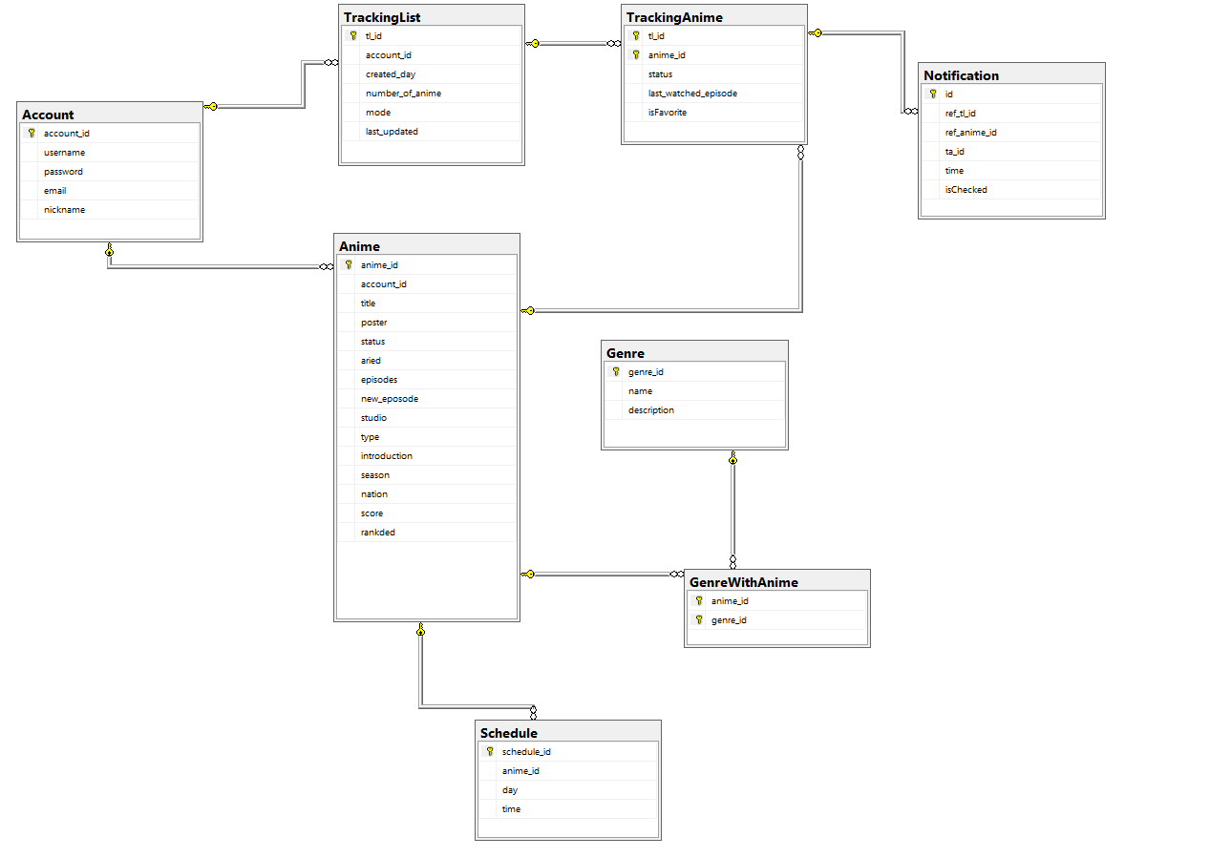

|  |
| --- |
| **Algorithm** |

1. **Administrator**

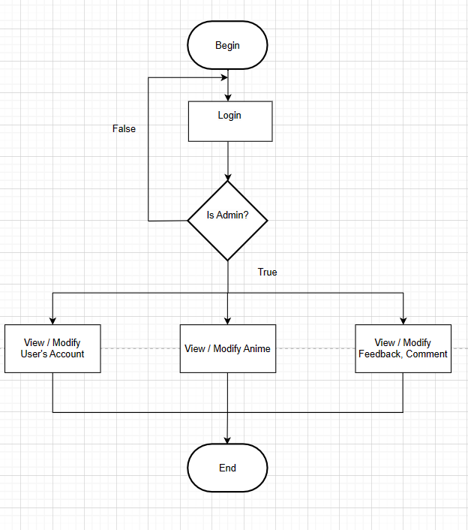

1. **User**

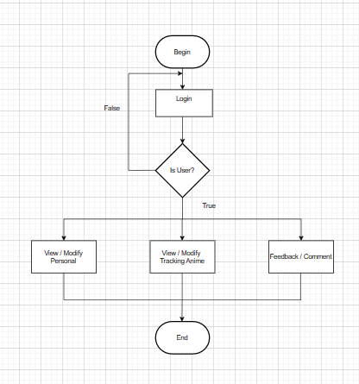

**Review 03**

|  |
| --- |
| **Screen shots** |

1. **Database Configuration:**

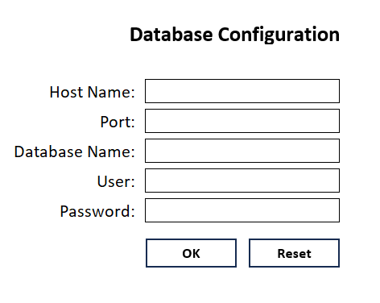

**Description** : The page edits the information to connect to the sql server

**From** : Do it before opening the App

**To** : Login Page

1. **Login and Register Form:**

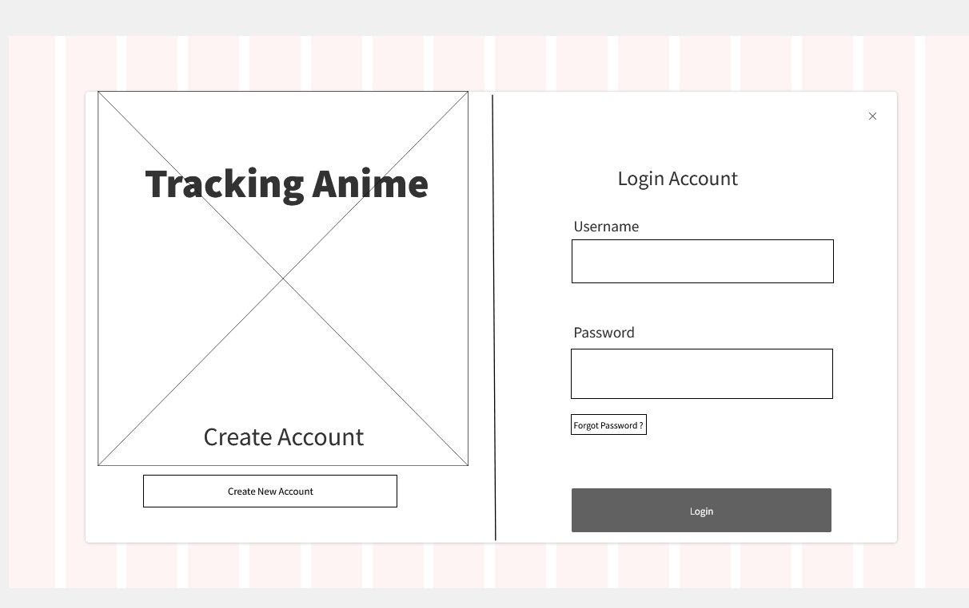

**Description** : Login Page

**From** : As soon as you open the app

**To** : Home Page

1. **Home Page**

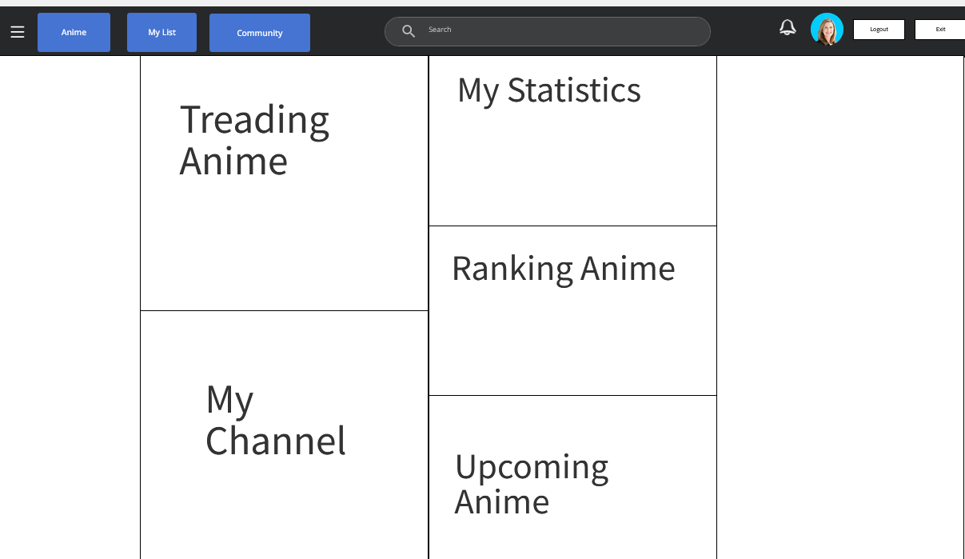

**Description** : Main page of a user account

**From** : Login Page

**To** : Tracking List, Anime

1. **Manage Account:**

**Description** : Modification Account Form

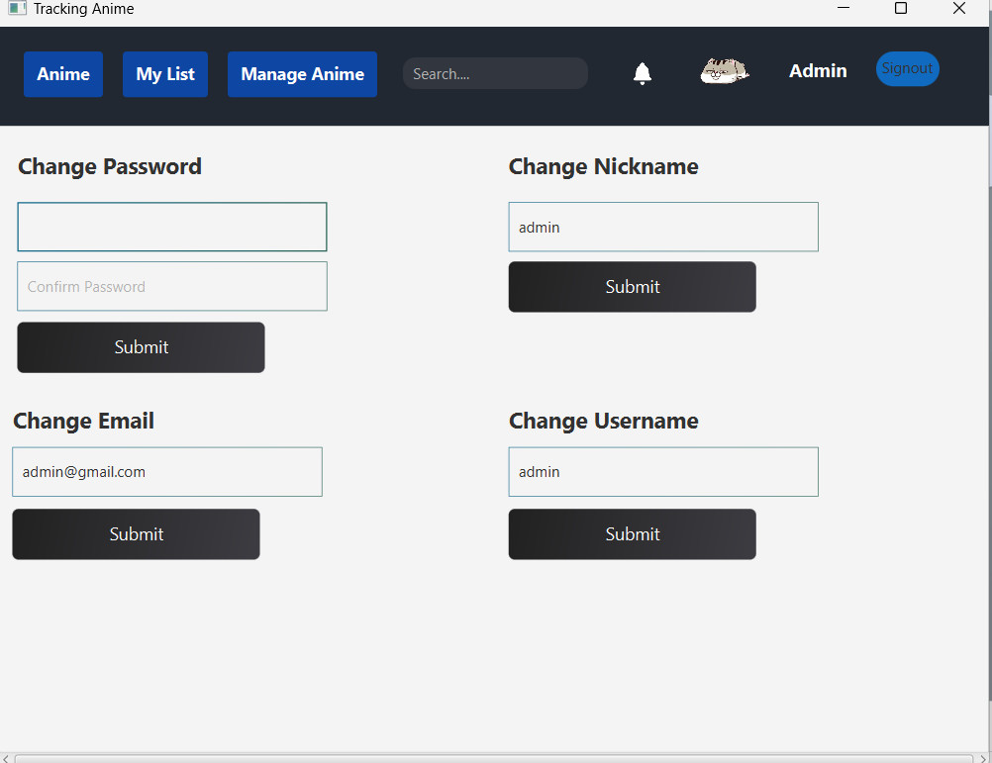

**From** : Preferences on Header from Account symbol

**To** : None

1. **Tracking List**

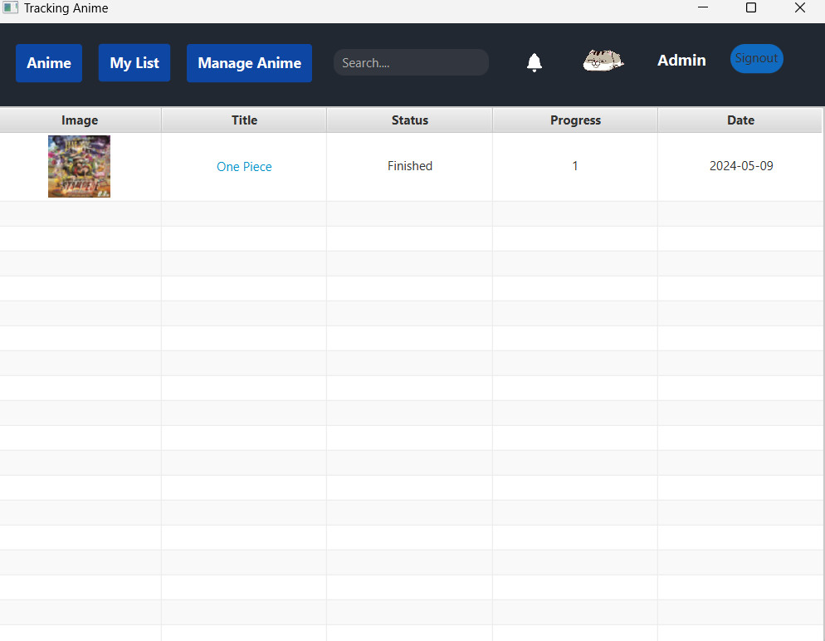

**Description** : List information about tracking anime list

**From** : My List button on Header

**To** : Anime, Notification

1. **Anime**

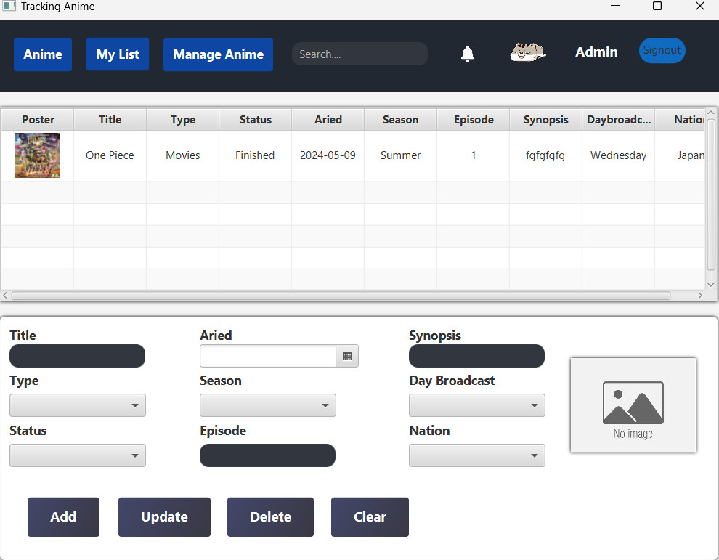

**Description** : Information about Anime and Form allow modify these anime

**From** : Manage Anime Button on Header

**To** : None

1. **Notification**

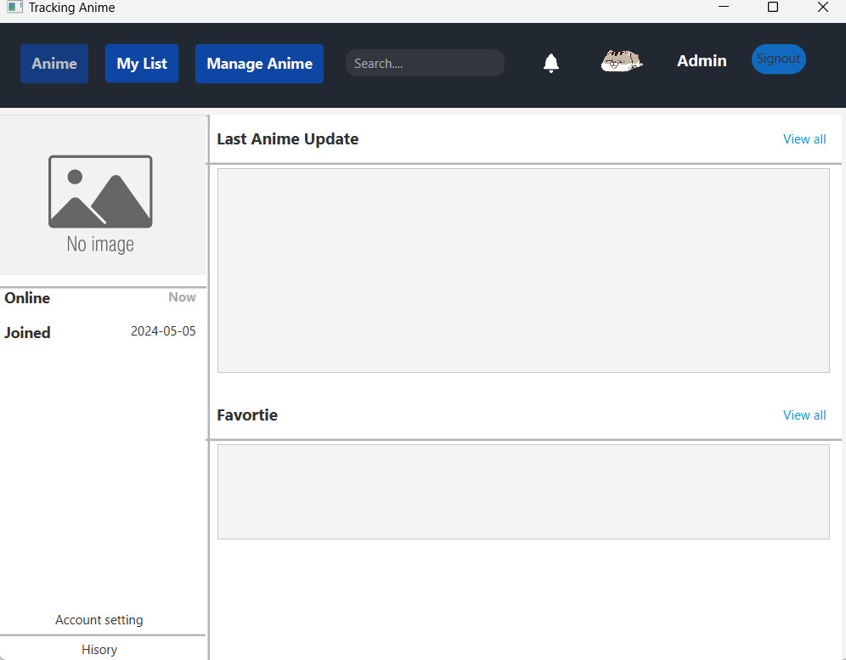

**Description** : Notification List about tracking anime list

**From** : Alarm symbol on Header or Tracking List

**To** : Anime, Tracking List

1. **Anime**

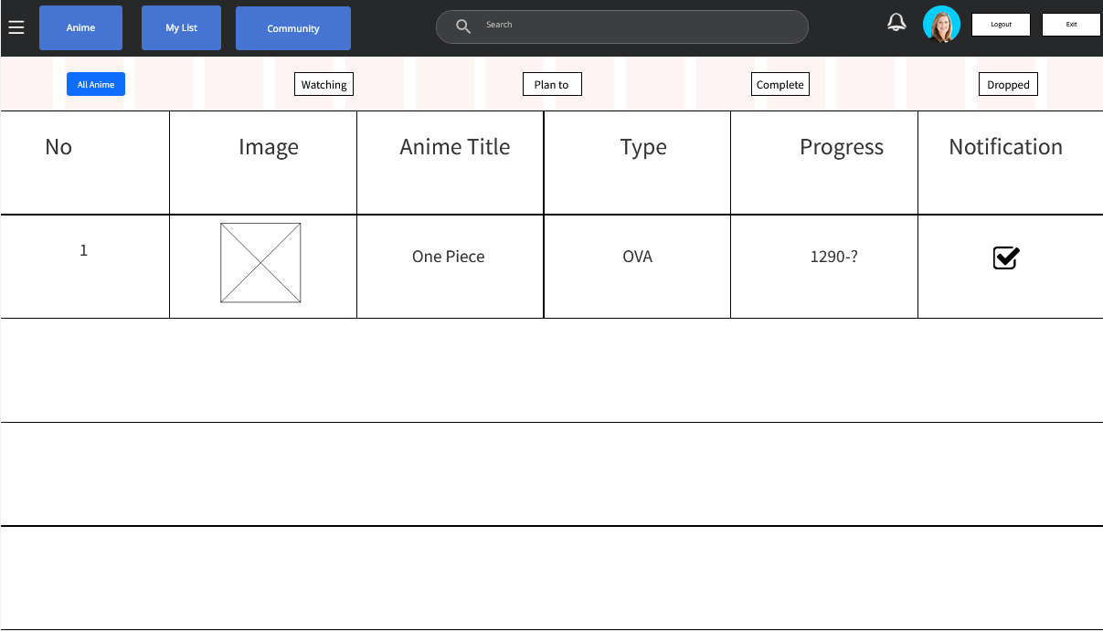

**Description** : Page for managing tracked Anime

**From** : Home Page or Header

**To** : Anime Page

|  |
| --- |
| **Testing document** |

|  |  |  |
| --- | --- | --- |
| **Sr.No** | **Features Tested** | **Remarks** |
| 1 | Test case | Pass |
| 2 | Test plan | Pass |
| 3 | Test scenario | Pass |
| 4 | Test report | Pass |
| 5 | Requirements Specification | Pass |
| 6 | Functional Specification | Pass |
| 7 | Use-Case Reports | Pass |
| 8 | Project Plan | Pass |
| 9 | Design Specifications | Pass |
| 10 | Prototype | Pass |
| 11 | User’s Manuals | Pass |
| 12 | Business Functions and Rules | Pass |
| 13 | Project or Business Risk Assessment | Pass |
| 14 | Responsibilities | Pass |
| 15 | Approvals | Pass |

|  |
| --- |
| **Final checklist** |

|  |  |  |
| --- | --- | --- |
| **Sr.No** | **Aspected Tested** | **Suggestion/**  **Remarks** |
| 1 | Are all the users able to view the images and links? | OK |
| 2 | Have all the views, modules and controllers been properly integrated and is the site function as a single page application? | OK |
| 3 | Are the GUI content devoid of spelling mistakes? | OK |
| 4 | Is the application user-friendly? | OK |
| 5 | Is the Website launching correctly in all popular browsers? | OK |
| 6 | Are all the forms validated with proper criteria? | OK |
| 7 | Do all text links lead to the appropriate website? | OK |
| 8 | Do all image links lead to the appropriate website? | OK |
| 9 | Are all the images and links clearly visible on the page? | OK |
| 10 | Does the Web page work properly in all the tested browsers? | OK |
| 11 | Does the Web page take too long to be loaded fully? | OK |
| 12 | Is the navigation sequences correct through all the Web pages on the site? | OK |
| 13 | Is the JavaScript code working as expected in all click events? | OK |
|  |  |  |
|  |  |  |

|  |  |  |  |  |  |  |  |  |
| --- | --- | --- | --- | --- | --- | --- | --- | --- |
| **No** | **Member** | **Contents** | | **Table Name** | **Activity Plan** | **Date of Preparation of Activity Plan** | | |
| **Planed Start Date** | **Actual Start Date** | **Actual Days** | **Status** |
| 1 | **Nguyễn Hoàng Anh Tú** | User |  | Account,  Tracking Anime |  |  | 5 | OK |
| 2 |  |  | 5 | OK |
| 3 | *Edit profile* |  |  | 5 | OK |
| 4 | *Anime management* |  |  | 5 | OK |
|  |  |  |  |  |  |  |  |  |
| 1 | **Lê Vinh Chí** | User |  | Tracking Anime, Tracking List, Notification |  |  | 5 | OK |
| 2 |  |  | 5 | OK |
| 3 |  |  | 5 | OK |
| 4 | *Check Notification.*  *Notification management* |  |  | 5 | OK |
|  |  |  |  |  |  |  |  |  |
| 1 | **Lê Trương Tín** | User |  | Anime , Tracking List |  |  | 5 | OK |
| 2 |  |  | 5 | OK |
| 3 | *Add and modify tracking list* |  |  | 5 | OK |
| 4 | *Search anime* |  |  | 5 | OK |
|  |  |  |  |  |  |  |  |  |
| 1 | **Nguyễn Trần Hoàng Long** | User |  | Anime, Tracking List, Feedback |  |  | 5 | OK |
| 2 |  |  | 5 | OK |
| 3 | *Modify Anime* |  |  | 5 | OK |
| 4 | *Manage Comment* |  |  | 5 | OK |